**Project C: 2**

# Cost cutting merging sites in one server

# **To create two EC2 instance for two different web sites:**

1. Node1
2. Node2

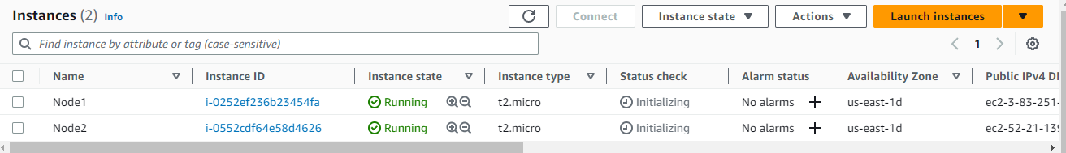

## -To connect both EC2 instance using putty software:

**Node1:**

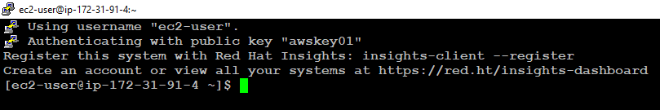

**Node2:**

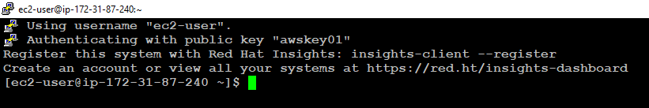

# **To Install Apache service on both Instance:**

## **-**Start apache and check status of an apache service on both server:

$sudo su -

#yum update -y

#yum install httpd -y

#systemctl start httpd

#systemctl status httpd

**Node1:**

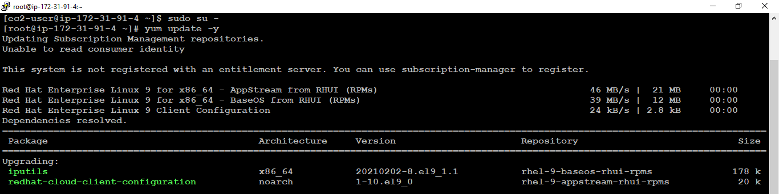

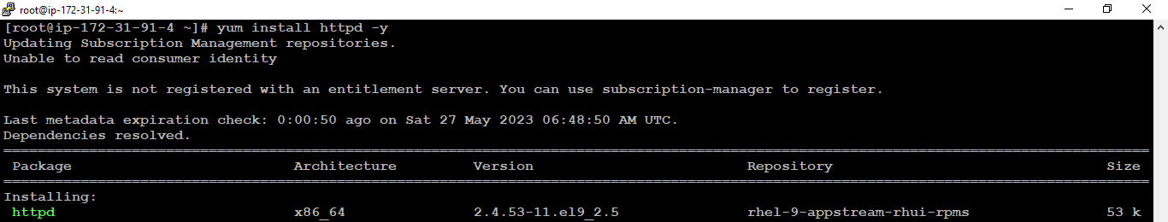

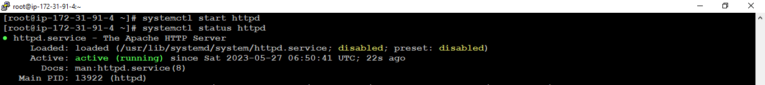

**Node2:**

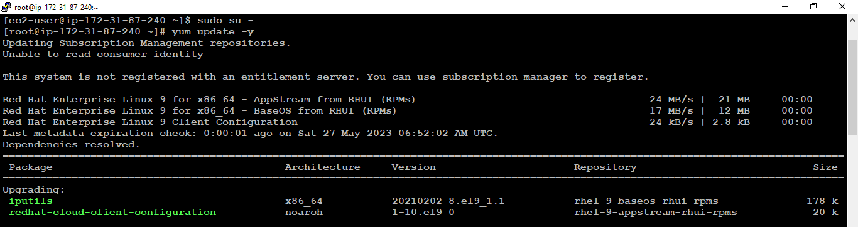

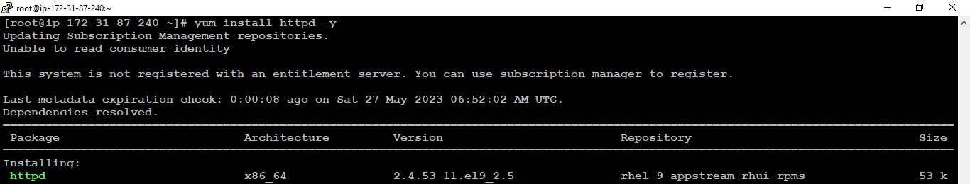



# **To copy the html file to document root on both instance:**

## -Document root: /var/ww/html/

#cd /var/www/html/

#vim index.html

#cat index.html

**Node1:**

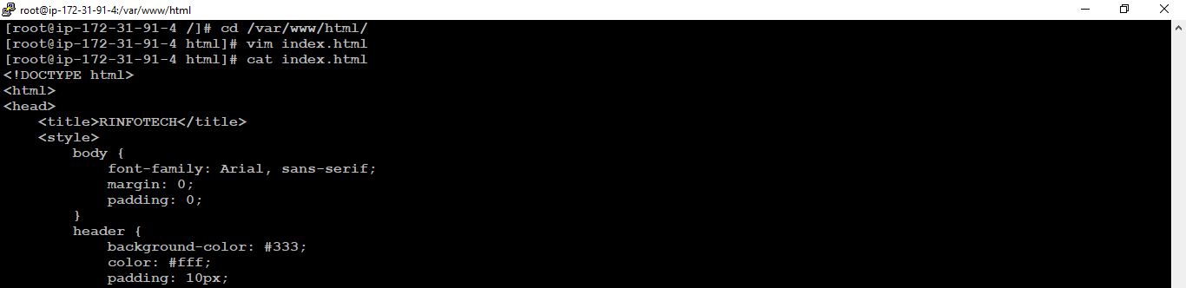

**Node2:**

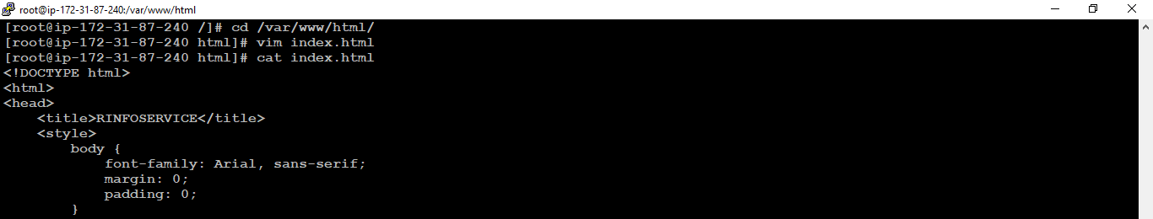

# **-To verify the both websites accessible or not:**

## -Find the public ip using the following command:

#curl ifconfig.me

**Node1:**



**Node2:**

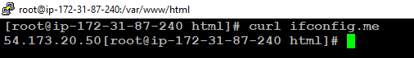

## -Go to web browser and enter the public IP

**Node1:**



**Node2:**

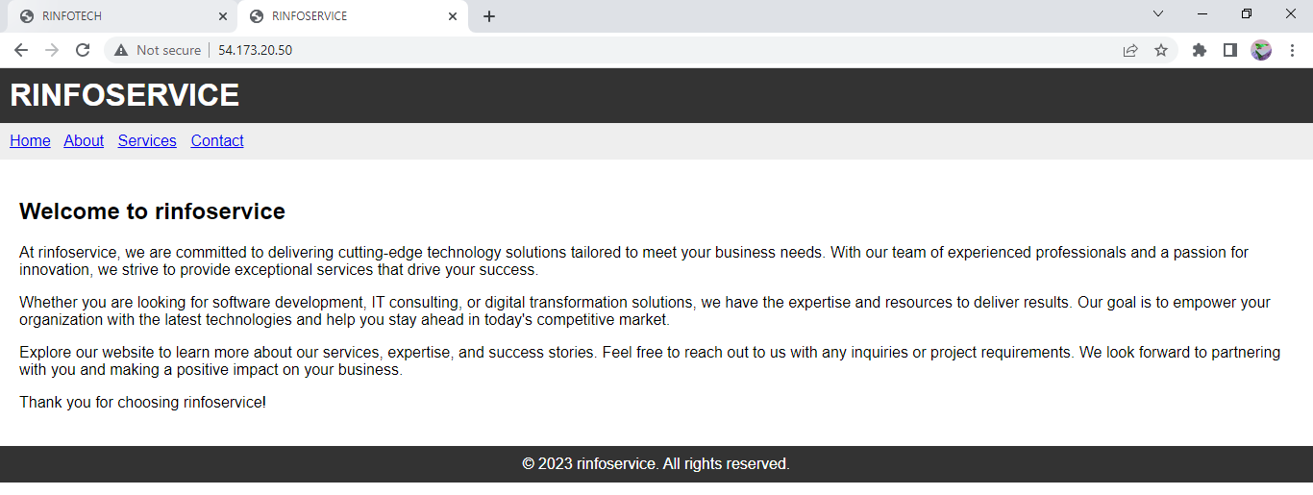

# **To create local DNS using the host file on physical machine windows:**

## -Win_10 host_file Path:

C:\Windows\System32\Drivers\etc\hosts

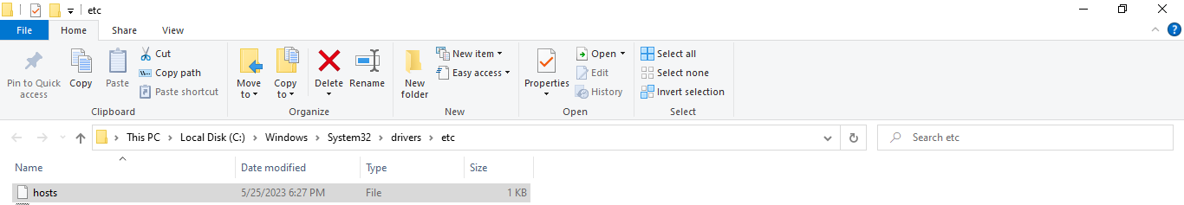

## -Edit the hosts by using the hosts file:

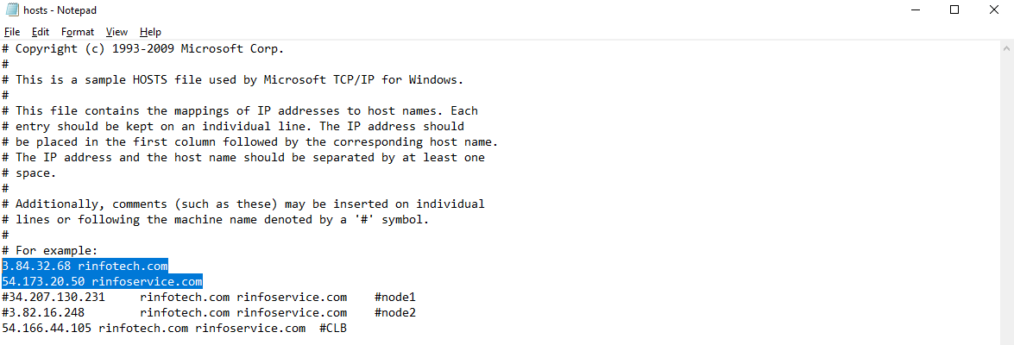

# **To verify the both websites accessible or not using local DNS name:**

**Win_10:**

## -Copy the Local DNS name from the host file:



## -Go to web browser and enter the Local DNS name:

**Node1:**



**Node2:**

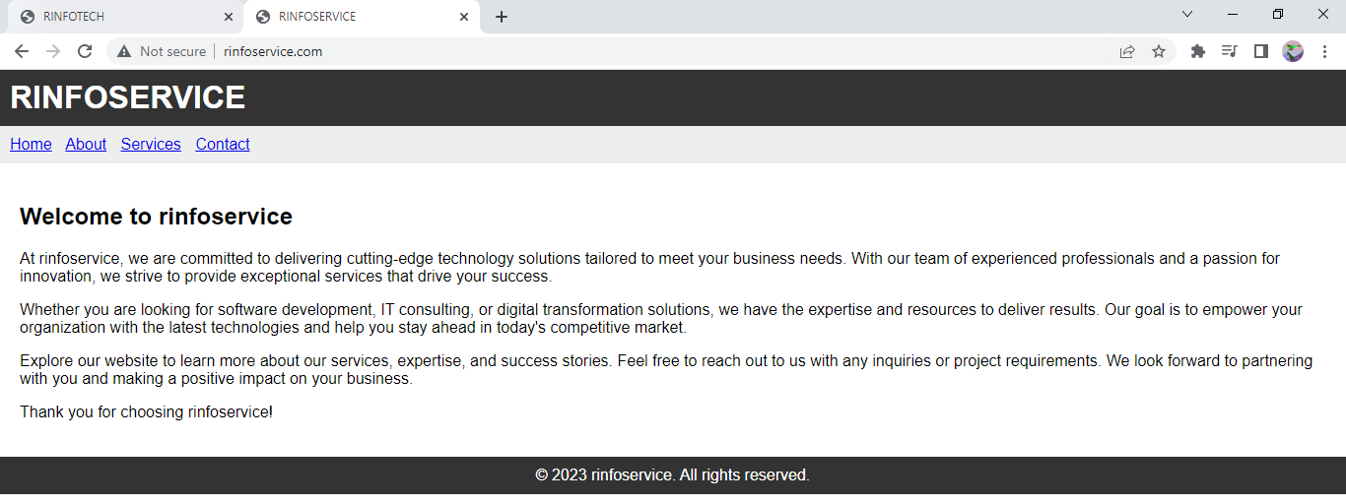

# **To merging the site (Node2) in one server (Node1) using the SCP (Secure Copy) for copy the doc. root file Node1:**

**Node2:**

## -Create the key pair using the following command:

#cd /var/www/html/

#ssh-keygen

## -Check and copy public key using the cat command:

#cat /root/.ssh/id_rsa.pub

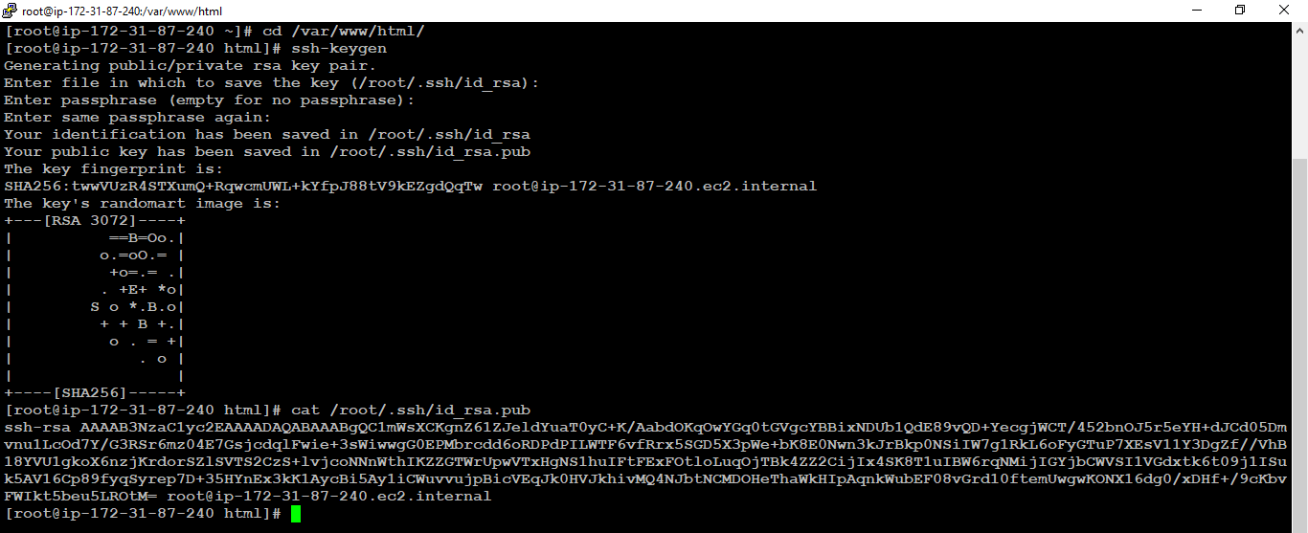

**Node1:**

#pwd

#cd .ssh

#ls –ltr

#vim authorization_key

Paste here generated public key



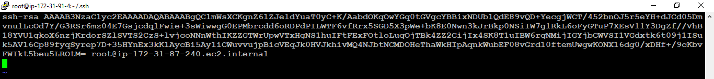

# **To check the SSH connectivity using the private ip address:**

**Node1:**

## -To check the private IP by using the following command:

#yum install net-tools -y

#ifconfig

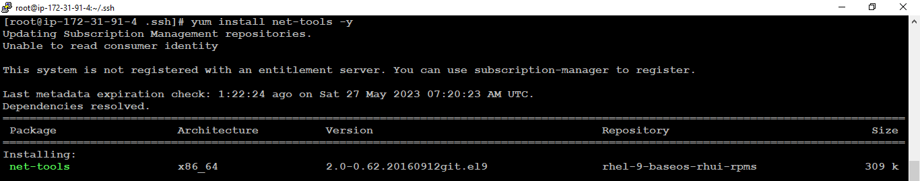

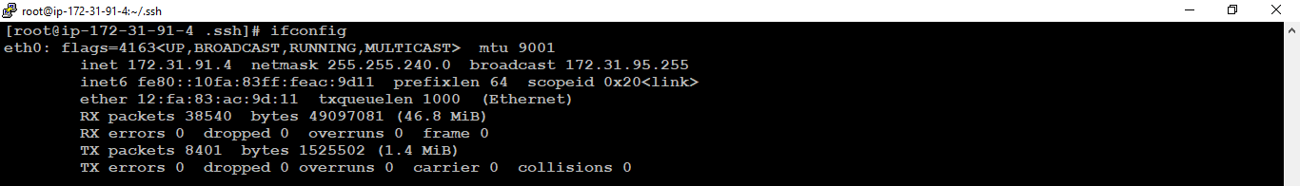

**Node2:**

## -To check the server connectivity using ssh connection:

#ssh 172.31.91.4

Ctrl+D = logout

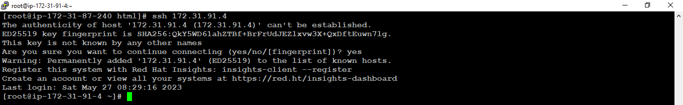

# **To Merge, copy and move the Node1, Node2 doc root to Node1 server:**

## -To create two directory /var/www/html in Node1 server:

**Node1:**

#cd /var/www/html/

#mkdir rinfotech rinfoservice

#ls –ltr

#cp index.html rinfotech

#ls -ltr

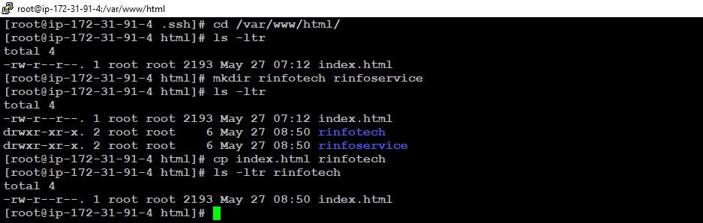

**Node2:**

## -To copy the index.html file to rinfotech directory:

#cd /var/www/html/

#ls –ltr

#scp index.html 172.31.91.4:/var/www/html/rinfoservice

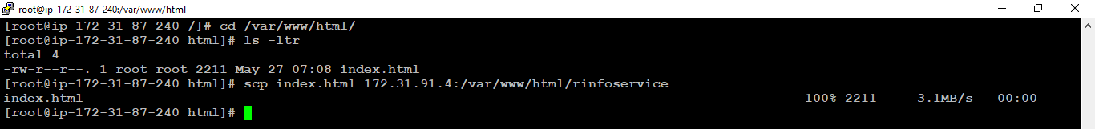

# **To verify the both index.html files or doc root:**

## -By using the following path: /var/www/html/

#ls –ltr

#ls –ltr rinfotech

#ls –ltr rinfoservice

**Node1:**



# **To merge the both websites in single point:**

**Win_10:**

## -By using the local DNS host file:

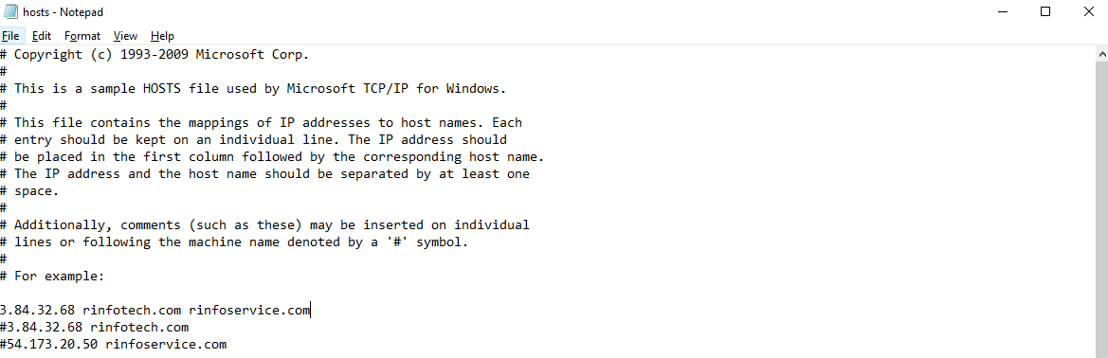

# **-To verify the both websites accessible on single node using local DNS name:**

## -By using the following paths:

<http://rinfotech.com/rinfotech/>

<http://rinfoservice.com/rinfoservice/>

**Node1:**



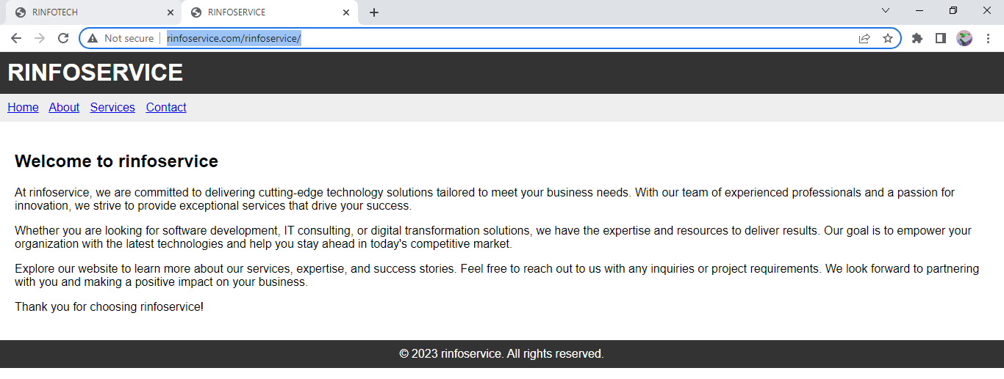

# **To create Virtual host configuration file for each domain on Node1 server:**

**Node1:**

## -Create virtual host in conf.d file

#cd /etc/httpd/conf.d

#ls –ltr

#vi virtualhost.conf

<Directory /var/www/html/infotech>  
        Require all granted  
        AllowOverride None  
</Directory>

<VirtualHost *:80>  
        DocumentRoot /var/www/html/infotech/  
        ServerName [infotech.com](http://abc123.com/)  
          
</VirtualHost>

<Directory /var/www/html/infoservice>  
        Require all granted  
        AllowOverride None  
</Directory>

<VirtualHost *:80>  
        DocumentRoot /var/www/html/infoservice/  
        ServerName [infoservice.com](http://xyz123.com/)  
          
</VirtualHost>



## -Reload, stop and start the apache service:

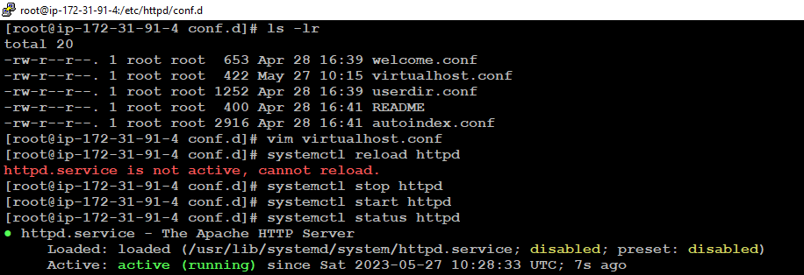

# **Assign ownership of the directories to the Apache user (usually 'apache') and grant appropriate permissions:**

## -Assign ownership and permissions:

**Node1:**

#chown -R apache:apache /var/www/html/rinfotech

#chown -R apache:apache /var/www/html/rinfoservice

#chmod -R 755 /var/www/html/rinfotech

#chmod -R 755 /var/www/html/rinfoservice

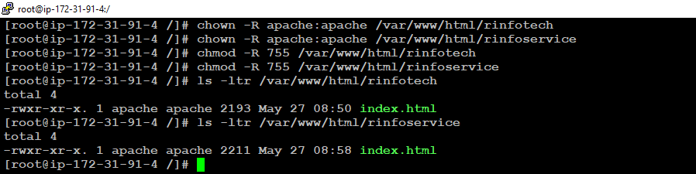

# **To verify the both websites accessible on single node (Node1) using local DNS name:**

## -Stop or terminate the Node2 server:

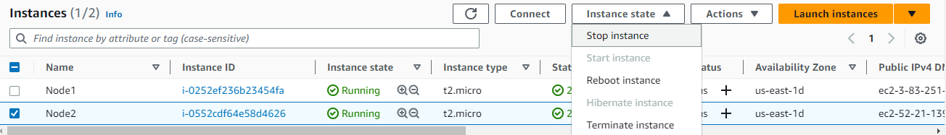

## -Running the both website on single node using the local DNS:

<http://rinfotech.com/>



<http://rinfoservice.com/>

